SCHOOL OF COMPUTER SCIENCE AND ARTIFICIAL INTELLIGENCE |  |  |  |  | DEPARTMENT OF COMPUTER SCIENCE ENGINEERING
Program Name: B. Tech |  |  |  | Assignment Type: Lab |  |  | Program Name: B. Tech
Course Coordinator Name |  |  |  | Dr. Rishabh Mittal
Hall ticket : |  |  |  | 2303A54070
Course Code |  |  | 23CS002PC304 | Course Code |  | 23CS002PC304
Year/Sem |  |  | III/II | Year/Sem |  | III/II
Date and Day  of Assignment |  |  | Week5 – Wednesday | Date and Day  of Assignment |  | Week5 – Wednesday
Name |  |  | M.ANU CHANDRA | BATCH |  | 48
AssignmentNumber:10.3(Present assignment number)/24(Total number of assignments)
 | Q.No. | Question |  |  |  |  |  | ExpectedTime  to complete
 | 1 | Lab 9 – Code Review and Quality: Using AI to improve code quality and readability  Lab Objectives:  • To apply AI-based prompt engineering for code review and quality improvement.  • To analyze code for readability, logic, performance, and maintainability issues.  • To use Zero-shot, One-shot, and Few-shot prompting for improving code quality.  • To evaluate AI-generated improvements using standard coding practices.  Lab Outcomes (LOs): After completing this lab, students will be able to:  • Review and improve code quality using AI tools.  • Identify syntax, logic, and performance issues in code.  • Refactor code to improve readability and maintainability.  • Compare AI outputs generated using different prompting techniques.  Problem Statement 1: AI-Assisted Bug Detection  Scenario: A junior developer wrote the following Python function to calculate factorials:  def factorial(n):  result = 1  for i in range(1, n):  result = result * i  return result  Prompt : #Ai Prmpt Used :  # Identify the logical bug in this factorial function.  # Explain why it occurs and provide a corrected version.  # Also consider edge cases like zero and negative numbers.  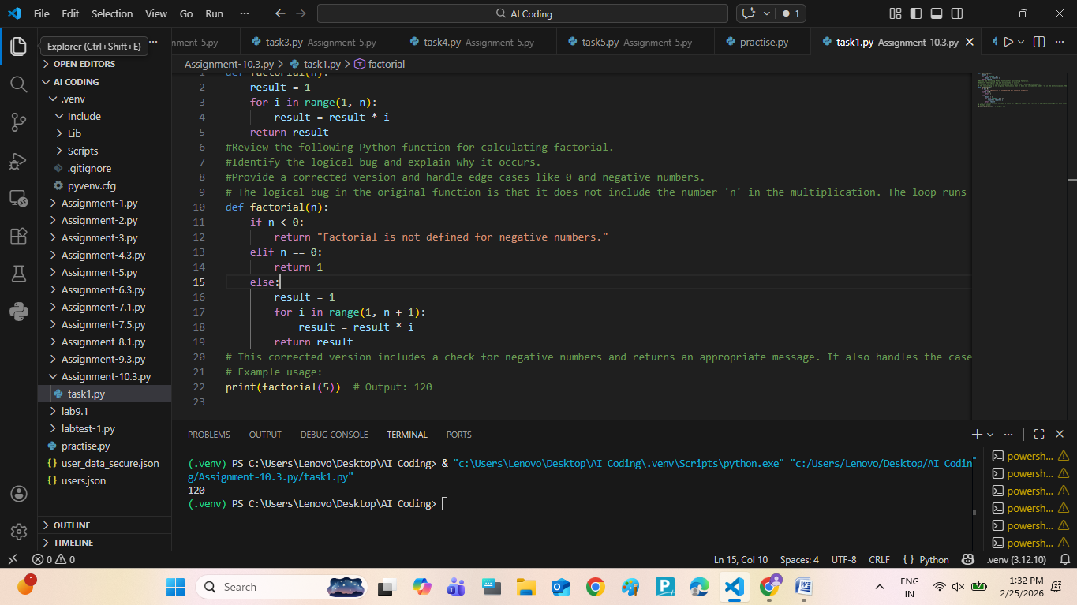  Expected Output:  Corrected function should return 120 for factorial(5).  Explanation : The bug happened because range(1, n) does not include n.  So for factorial(5), it multiplied only up to 4.  This is called an off-by-one error.  AI fixed it by using range(1, n + 1) and also handled negative numbers.  Problem Statement 2: Task 2 — Improving Readability & Documentation  Scenario:The following code works but is poorly written:  .  def calc(a, b, c):  if c == "add":  return a + b  elif c == "sub":  return a - b  elif c == "mul":  return a * b  elif c == "div":  Prompt : #Improve this function for readability.  #Rename parameters clearly.  #Add a proper docstring.  #Handle division by zero.  #Add input validation.  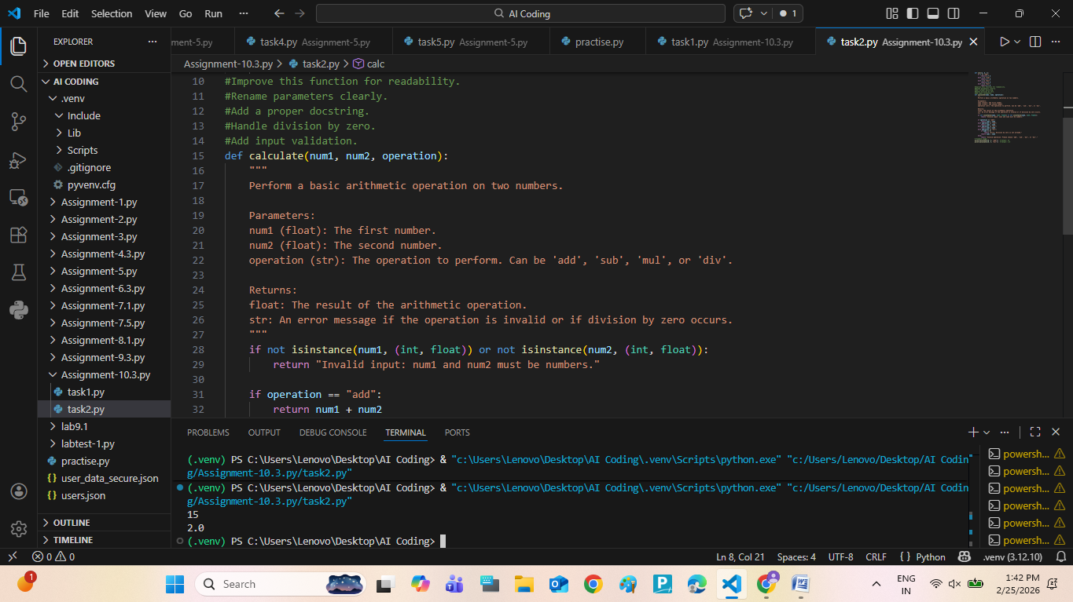  Expected Output:  A well-documented, robust, and readable function that handles errors gracefully.  Explanation : Original function had poor naming and no documentation.  AI improved parameter names, added docstring, and added error handling.  Now the function is readable and safe.  Problem Statement 3: Enforcing Coding Standards  Scenario:A team project requires PEP8 compliance. A developer submits:  def Checkprime(n):  for i in range(2, n):  if n % i == 0:  return False  return True  Prompt : #Review the following Python function for checking if a number is prime.  #Identify any logical bugs and explain why they occur.  #Provide a corrected version and handle edge cases like numbers less than 2.  #The logical bug in the original function is that it does not handle numbers less than 2, which are not prime. Additionally, it does not include a check for the number 2, which is the smallest prime number. The function will incorrectly return True for numbers like 0 and 1, which are not prime.  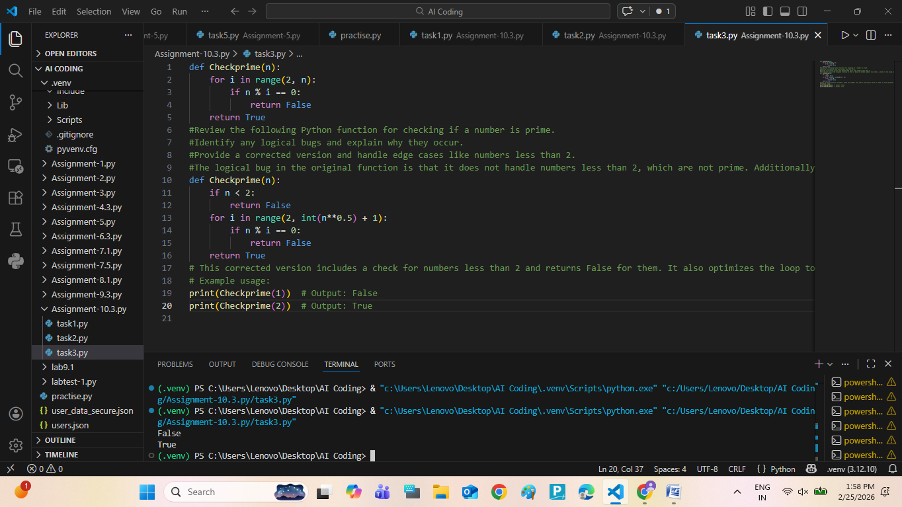  Expected Output:  A PEP8-compliant version of the function, e.g.:  def check_prime(n):  for i in range(2, n):  if n % i == 0:  return False  return True  Explanation : In this task, we improved the code to follow PEP8 standards. The original function worked, but the naming style was incorrect and there was no documentation. AI suggested using lowercase function names, proper spacing, and adding a docstring. After changes, the code became more readable, clean, and professional.  Problem Statement 4: AI as a Code Reviewer in Real Projects  Scenario:  In a GitHub project, a teammate submits:  def processData(d):  return [x * 2 for x in d if x % 2 == 0]  Prompt : #Review the following Python function for processing a list of numbers.  #Identify any logical bugs and explain why they occur.  #Provide a corrected version and handle edge cases like empty lists or non-numeric values.  #The logical bug in the original function is that it does not handle non-numeric values in the list, which could lead to a TypeError when trying to perform the multiplication. Additionally, it does not handle the case of an empty list, which should simply return an empty list without errors.  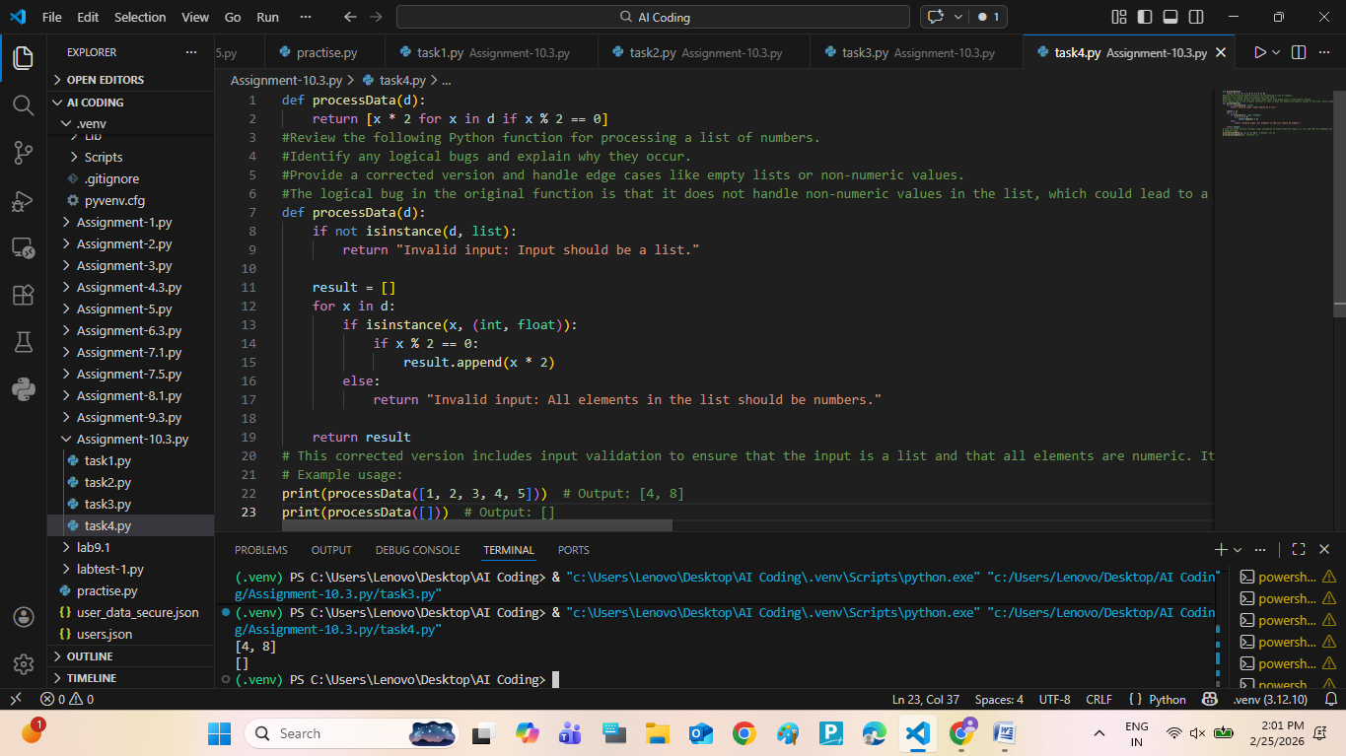  Expected Output:  An improved function with type hints, validation, and clearer intent, e.g.:  from typing import List, Union  def double_even_numbers(numbers: List[Union[int, float]]) -> List[Union[int, float]]:  if not isinstance(numbers, list):  raise TypeError("Input must be a list")  return [num * 2 for num in numbers if isinstance(num, (int, float)) and num % 2 == 0]  Explanation :  Problem Statement 5: — AI-Assisted Performance Optimization  Scenario:You are given a function that processes a list of integers, but it runs slowly on large datasets:  def sum_of_squares(numbers):  total = 0  for num in numbers:  total += num ** 2  return total  Prompt : #Review the following Python function for calculating the sum of squares of a list of numbers.  #Identify any logical bugs and explain why they occur.  #Provide a corrected version and handle edge cases like empty lists or non-numeric values.  #The logical bug in the original function is that it does not handle non-numeric values in the list, which could lead to a TypeError when trying to perform the exponentiation. Additionally, it does not handle the case of an empty list, which should simply return 0 without errors.  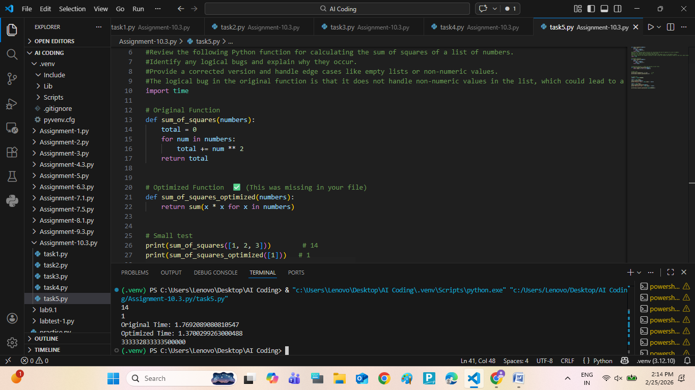  Expected Output:  An optimized function, such as:  def sum_of_squares_optimized(numbers):  return sum(x * x for x in numbers)  Explanation : In this task, we optimized a function that calculates sum of squares. The original version used a loop. AI suggested using Python’s built-in sum() function, which is faster and more readable. The time complexity remains O(n), but performance improves slightly. |  |  |  |  |  | Week5 - Wednesday

